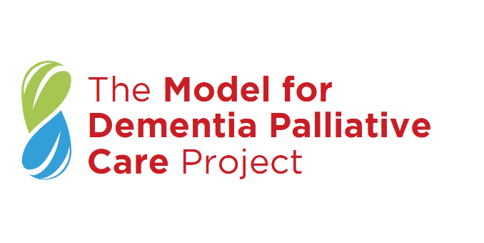
Help Shape Future Models of Dementia Palliative Care - We Want to Hear From You!
We want to hear from healthcare workers, policy-makers, researchers, and other professionals with an interest in Dementia palliative care. Your contribution matters – complete the survey and have your say!

What is the survey about?
As part of The Model for Dementia Palliative Care Project, we are conducting a survey of healthcare professionals and researchers to find out:
A) What they feel is most important in a model of palliative care for people with dementia living in the community?
B) What existing Dementia Palliative Care services are there?

Who should take part?
Any healthcare worker, policy-maker, researcher, or other professional with an interest in dementia and/or palliative care, working in Republic of Ireland, Northern Ireland, Scotland, England or Wales. We want to hear from as many people as possible, all views are valid.

How long will it take?
Around 10-15 minutes, depending on how much information you want to provide.

How can I take part?
To find out more information, and/or to take part in the survey click here: https://sulis.ucc.ie/limesurvey/index.php/25183?lang=en

Where can I find out more?
This survey is part of The Model for Dementia Palliative Care Project. To find out more about this project visit www.PallCare4Dementia.com and follow us on twitter @PallC4Dementia. If you have any further questions, you can also contact the postdoctoral researcher Dr Siobhán Fox by email at s.fox@ucc.ie.

