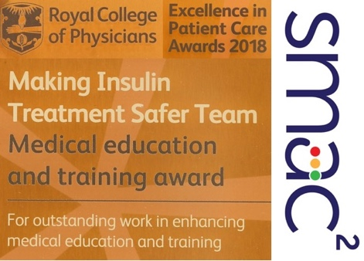
The MITS Team has won the RCP’s 2018 Education

Award for Excellence in Patient Care

What is MITS?
- MITS stands for 'Making Insulin Treatment Safer'. It uses the SMAC² reflective tool to help insulin prescribers develop 'situation awareness'. SMAC² empowers prescribers to acknowledge when they are uncertain. It encourages them to seek information and supplement their personal resources by involving patients, fellow professionals, and seniors.

Why is MITS needed?
- The glycemic control of hospitalised diabetic patients is often poor and 1 in 25 of them develops ketoacidosis or HHS after being admitted to hospital.

- At least two thirds of insulin prescriptions are written by foundation doctors. Usually FY1s, and usually without close supervision. Their error rate is high.

- The culture of clinical workplaces does not encourage FDs to acknowledge uncertainty; blaming and scapegoating occur.

How MITS works
- SMAC² stands for 'Situation', 'Myself', 'Act?', 'Check', and 'Check again'. This rule of thumb helps FDs appraise challenging situations and respond to them safely.

- Lanyard cards provide 'hot tips' to insulin safety and help FDs apply the SMAC² rule of thumb.

- FDs use SMAC² to analyse a situation that challenged them and (by appointment) participate in a 'case-based discussion' with a trained debriefer, who helps them identify learning points they can apply to future situations.

- MITS takes a systems approach to insulin prescribing. It identifies learning points from specific events.

- MITS does not blame but shows kindness and understanding. It actively involves patients in their own care and encourages doctors to work closer with other professionals.

What MITS has achieved
- MITS has conducted case-based discussions (CBDs), which debriefed 113 FDs (including 40% of FY1s in NI) on educative experiences of prescribing insulin. MITS empowered them to prescribe more safely in future.

- To conduct those case-based discussions, MITS trained 58 doctors, pharmacists, nurses, and service users in empowerment techniques.

- MITS has analysed records of those debriefs to identify threats to patient safety and help FDs navigate these better in future

- This analysis has shown, for example, how day staff fail to prescribe insulin proactively and leave on-call FDs to do so reactively when senior help is least available.

For further information, contact Deborah Millar (Deborah.Millar@qub.ac.uk) or Tim Dornan (t.dornan@qub.ac.uk)

